Set 1
Q1 : Write a HTML code to generate the following output
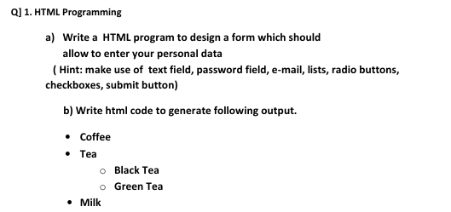

Q2 : Write a HTML code to generate the following output
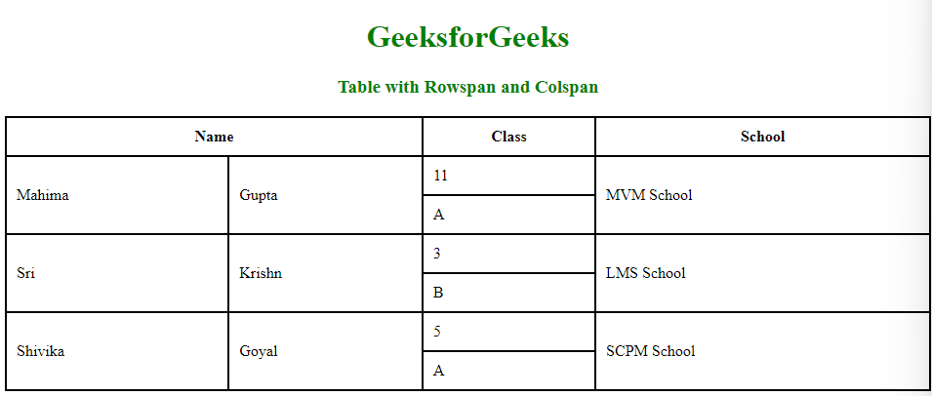
Q3
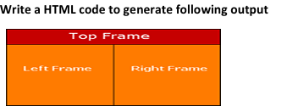
Q4
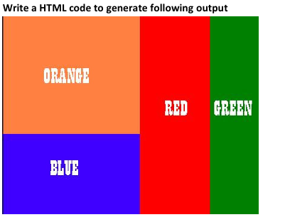

Q5 Write HTML Code to generate the following Output
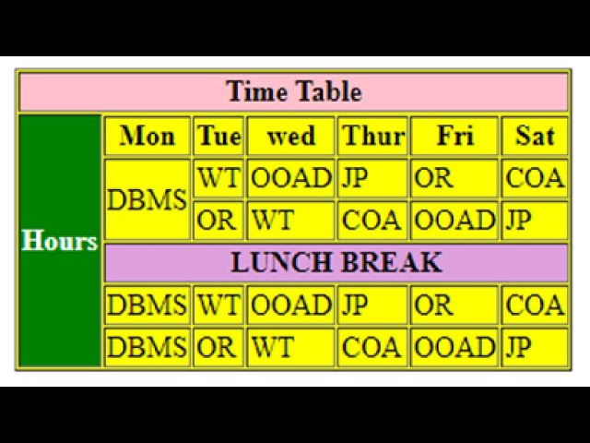

Q6 Write HTML Code to generate the following Output
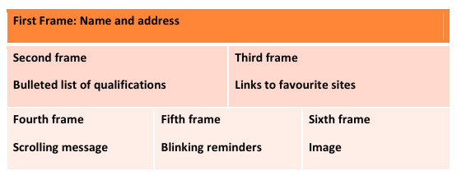
Q7
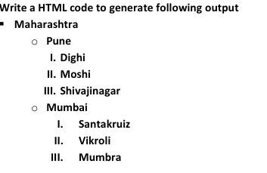
Q8 Write the HTML code to generate the following output
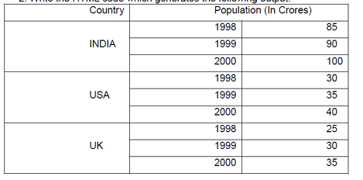
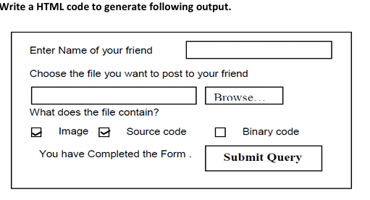
Q9

Q10 Write a HTML Code that generates the following output
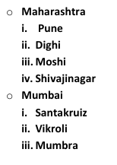
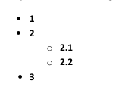
Q 11: Write a HTML Code that generates the following output.
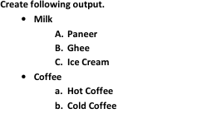
Q 12: Write a HTML Code that generates the following output.

Q 13: Write a HTML Code that generates the following output.
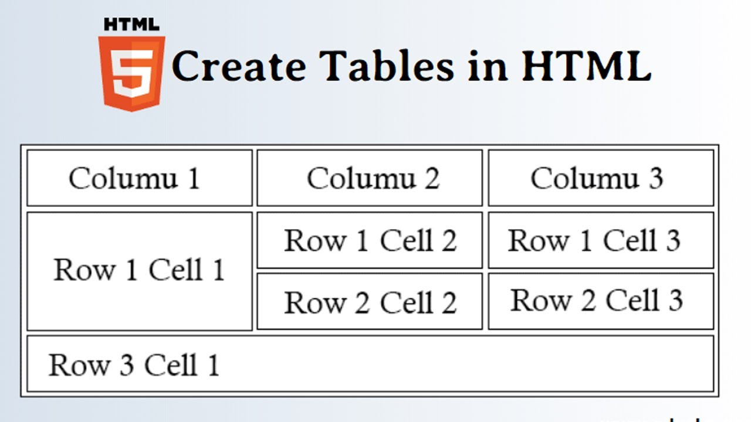

Q 14: Write a HTML Code that generates the following output.
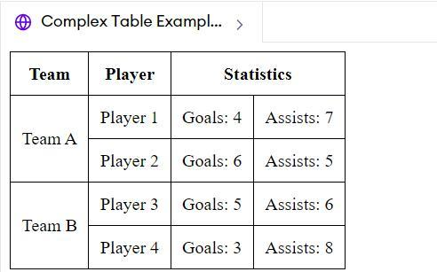
Q 15: Write a HTML Code that generates the following output.
